Sheet 1: Brainstorming Name: Karin Date: 2/15/2024
Ideas
Googled and used ChatGPT to get ideas on different charts to use to show simple ranked data, which suggested most of the charts below:
- Bar charts 2. Ranked List/Table Chart 3. Pareto Chart
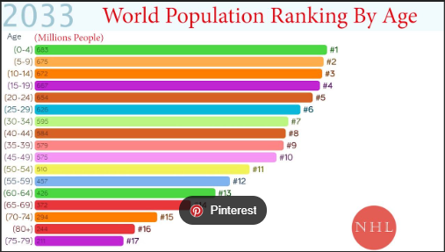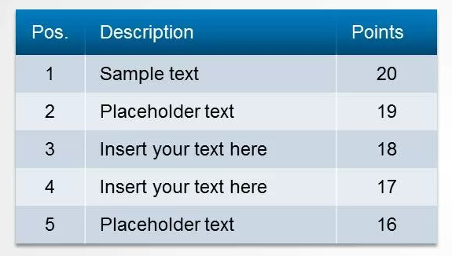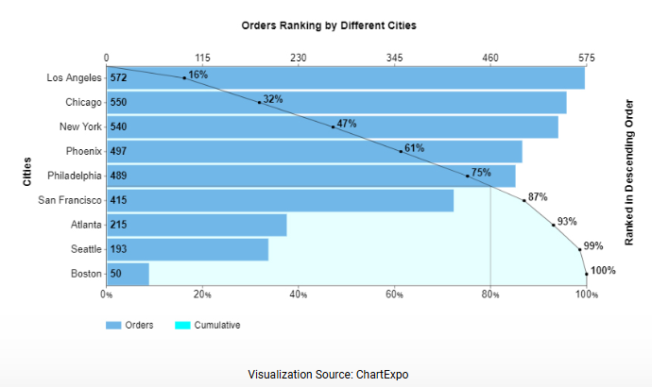
4. Pie Chart 5. Scatter Plot 6. Sequence Chart
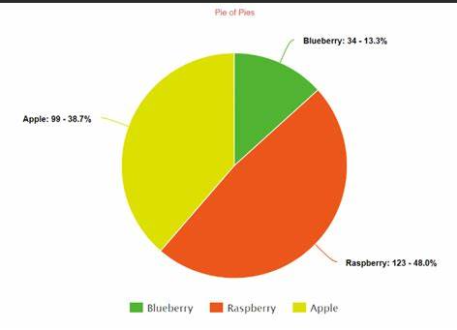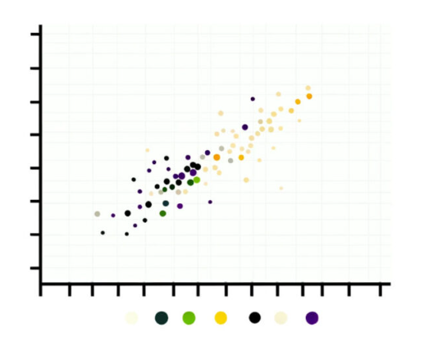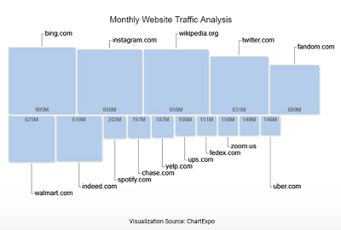
7. Slope Chart 8. Sankey Chart 9. Box Plot
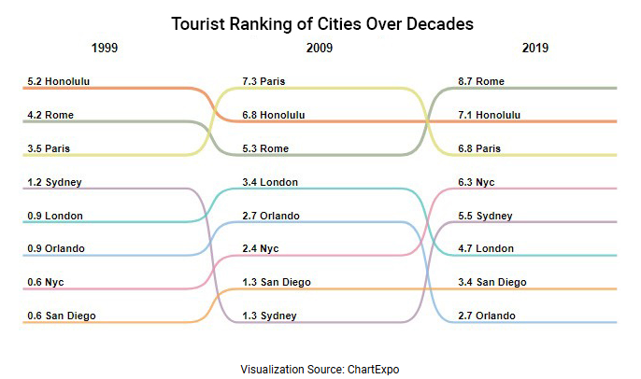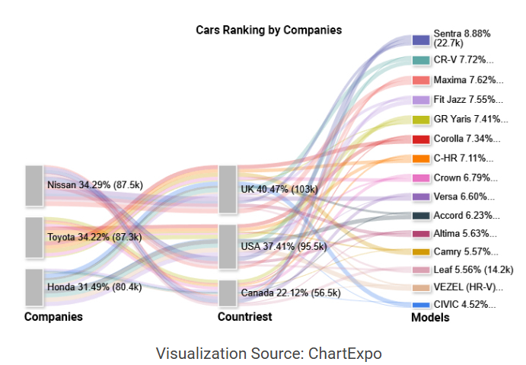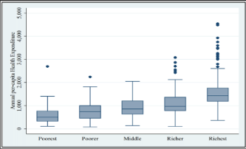
10. Stacked Column Chart 11. Heatmap 12. Likert Scale Chart 13. Grouped Bar Chart
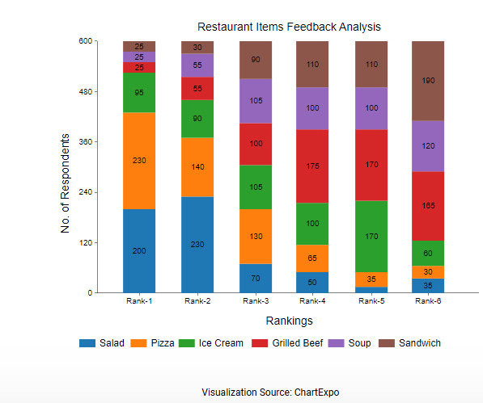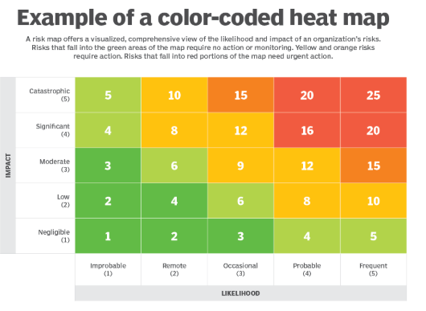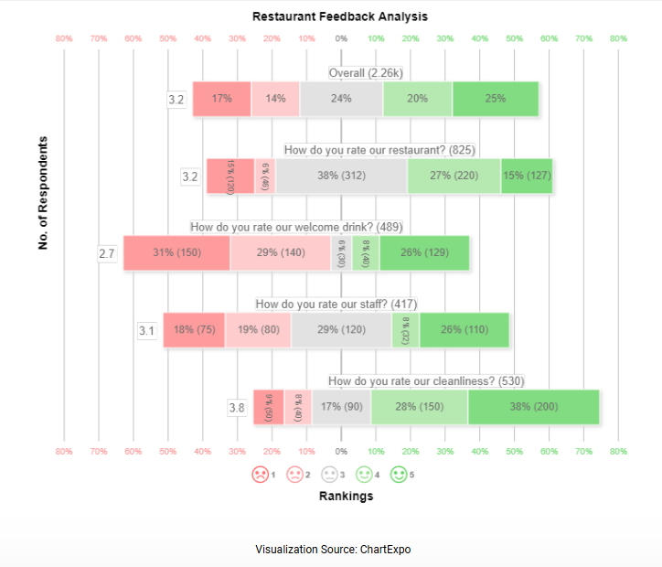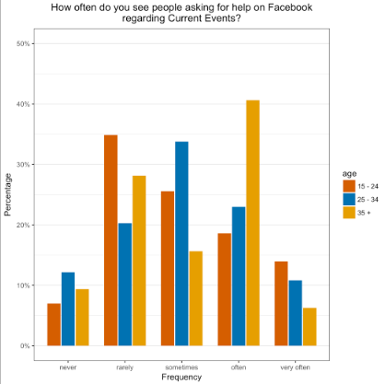

Filter: The following charts are too complicated and hard to read or do not make sense to use for my goals:

- Slope
- Sankey
- Pareto
- Pie
- Scatter
- Stacked Column
- Heatmap
- Likert Scale

Categorize:

- View categorization:
  - bars/lines views – allows users to
    - Bar
    - Ranking list/table
    - Grouped Bar
  - Boxy views
    - Sequence
    - Box plot

- Easy to explore the data
  - Bar/lines view – allow me to see the individual movie data and then I can filter and group it in different ways
  - Boxy views – aggregates the individual movie data first by some other category. Then I have to hover over or click to drill into it to see the actual movie data

Combine & Refine:
Have some type of bar chart with different options to sort and filter the list to view the data in different ways.
- Ways to filter/sort data:
  - Sort by
    - Average Rating in asc or desc order
    - Title name asc or desc order
  - Fitler by
    - a specific rating value or range
    - Director
    - Release Date
- Ways to categorize data:
  - Average rating range: 0-2, 3-4, 5-6, 7-8, 9-10 (high-level goal)
  - Director – category (high-level goal)
  - Release year (based upon date) - category
  - Country of Origin – category data
  - Languages – category data
  - Runtime – linear date

Question:
- Will the user be able to view which movies had the highest Average Rating (maybe as well as the lowest ratings) and the other details about these movies? Yes
- Will the user be able to see if there are any patterns between those movies that have the highest (or lowest) Average Rating and Director. Yes .. the combination of the ability to be able to both filter and sort the data should allow users to view different combinations of data to identify relationship patterns between the Directory and the Average Rating.
Sheet 2: Bar Chart mockup
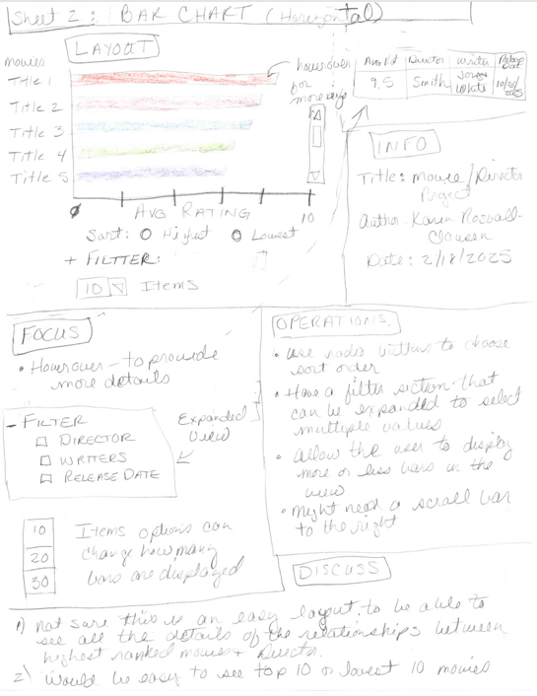
Sheet 3: Grouped Bar mockup
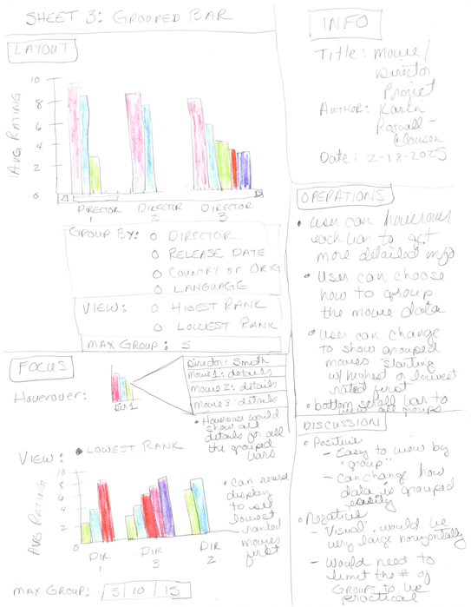
Sheet 4: Stacked Rank List/Table mockup

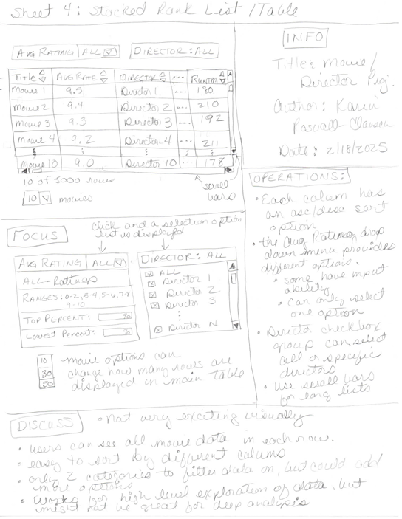
Sheet 5: Realization mock up

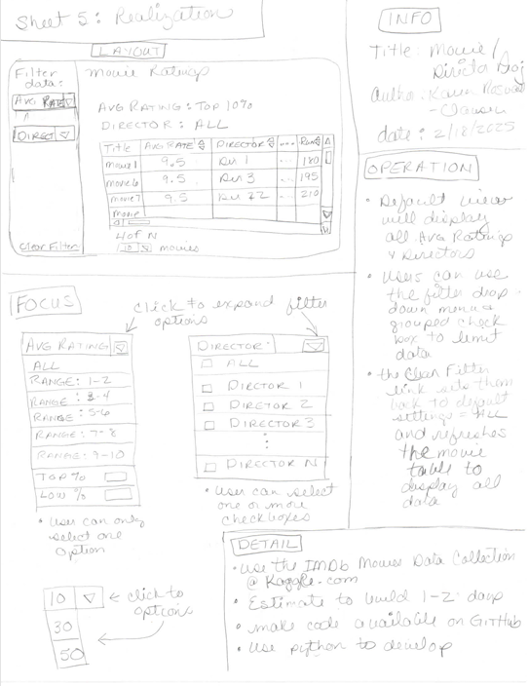
Outline a preliminary evaluation that addresses your core goals with the visualization. Make sure your evaluation discusses:
- The target question you want to answer
  - Question: Is there a pattern between a movie’s rating and the Director?
- The people you would recruit to answer that question
  - Family and friends because the visualization is intended to be used strictly for enjoyment.
- The kinds of measures you would use to answer your data (e.g., insight depth, use cases, accuracy) and what these measures would tell you about the core question
  - When first viewing the visualization, do users understand how to be able to view the highest / lowest list of movies?
  - Are users able to easily and quickly understand how to use the visualization to filter and sort the movie list by Average Rating and Director?
  - Does visualization enable users to see/understand if there are any patterns between:
    - Who the Director is for those movies with the highest Average Rating?
    - If a specific Director tends to have movies with higher Average Ratings than other Directors?
- The approach you will use to answer that question (e.g., a journaling study, a formal experiment, etc.)
  - A formative -> qualitative approach specifically a Thinkaloud study of the visualization.
- How would you instantiate those methods (i.e., what would your participants do?)
- Participants would be asked to navigate to the prototype of the visualization and before they do any interactions with the visualization, provide feedback on a scale from 1(do not like) – 5 (like it very much)
  - Do they like the default layout and display (colors, fonts) of the visualization
  - Do they understand how they would use the visualization to learn
    - which movies have the highest / lowest Avg Rating
    - how they could use the filter and sort options to find out if there is a pattern between the movie’s Director and the Avg Rating
- After these first questions, then the user would be asked to play around with the visual to see if their first impressions were correct when they actually use the visualization to try to answer the above questions
- Users would then be asked to provide additional feedback on what they liked and didn’t like about
  - the layout and display changes during their actual use of the visualization
  - the navigation steps to be able to change the visualization to be able to see the patterns on movie Avg Rating and Directory data
  - Was the visualization confusing and hard to understand how to use or was it easy and intuitive
  - For any result provided that is 3 or below, ask the participant to provide specific information about why they provided the avg to lower rating for specific question.
- What criteria would you use to indicate that your visualization was successful
- If each of the criteria above scored between 4-5 for 80% of the participants involved in the study.
- For those results that did not fall within the successful criteria above, further investigation would be made to try to understand the exact reason behind the specific result.
- Did the user does not understand the assignment and this caused confusion with how they thought they were being asked to respond (was the question not worded in a clear and easy to understand way)
- Did they make a mistake and provided an incorrect answer
- Read the detailed information provided regarding the rating to see if there are any patterns in the average to lower results given.

